**A**

**Report On**

**A Modified Self Chargeable adapter for charging the electronic devices under 5 V & 2 amp**

Under supervision of

**DR. Mohmmad Ahmad**

(Assistant Professor)

**Department of Electrical Engineering**

Submitted By:

**Vishal Kumar (Roll No.: 2107350200053)**

**Shivam (Roll No.: 2107350200044)**

**Ravi Shivam (Roll No.: 2107350200037)**

**Submitted to the Department of Electrical Engineering in**

**Partial fulfilment of the requirements for the degree of**

**Bachelor of Technology**

**In Electrical Engineering**

**Session: 2024 – 2025**



**Submitted To:**

**Dr. Archana Sharma & Dr. Navneet Kumar**

**(Assistant Professor, Department of Electrical Engineering)**

**Rajkiya Engineering College, Bijnor, Uttar Pradesh 246725**

**Affiliated to Dr. A P J Abdul Kalam Technical University, Lucknow, U. P****.**

**Department of Electrical**

**Engineering Rajkiya Engineering**

**College Bijnor, Uttar Pradesh**

(Affiliated to Uttar Pradesh

 Technical University, Lucknow)

**CERTIFICATE**

We hereby declare that the work is presented in this project entitled “A modified Self chargeable adapter for charging the electronics device under 5 V &2 Amp” in partial Fulfillment for the award of degree of Bachelor of Technology in Electrical Engineering submitted in the Department of Electrical Engineering, Rajkiya Engineering College Bijnor (Affiliated to Uttar Pradesh Technical University, Lucknow) is our own work carried out, under the guidance of Dr. Mohmmad Ahmad, Asst Prof of Electrical Engineering, Dr. Navneet Kumar Project Coordinator and Dr. Archana Sharma Head of Department of Electrical Engineering.

Vishal Kumar Shivam Ravi Shivam

2107350200053 2107350200044 2107350200037

This is Certify that above statement made by the candidates are correct to the best of my knowledge.

Under the supervision of Head of department

Dr. Mohmmad Ahmad Dr. Archana Sharma

Assistant Professor Assistant Professor **ACKNOWLEDGEMENT**

We take this opportunity express our profound gratitude and deep regards to our guide **Dr. Mohmmad Ahmad** for his exemplary guidance, monitoring and constant encouragement throughout the course of thisreport. The blessing, help and guidance given by his time to time shall carry us a long way in the journey of our life on which we are about to embark.

We also take this opportunity to express a deep sense of gratitude to our honorable Head of the Department **Dr. Archana Sharma** for his cordial support, valuable information and guidance, which helped me in completing this task through various stages.

We are obliged to **Dr. Mohmmad Ahmad, Dr. Navneet Kumar** for the valuable information provided by them in their respective fields. We are grateful for their cooperation during the period of our Project.

Lastly, we thank our friends for their constant encouragement without which this Project would not be possible.

**Name:**

**Vishal Kumar (210735020053)**

**Shivam (210735020044)**

**Ravi Shivam (210735020037)**

**TABLE OF CONTENT**

Contents Page no.

CHAPTER-1 7

INTRODUCTION 7

CHAPTER-2 8

DISCPTION OF THE PROBLEM 8

2.1 Detailed Explanation of the Problem 8

2.2 Key Components for Charging 8

2.3 Core Problem 8

2.4 Existing Solutions and Their Limitations 8

2.5 The Gap in Existing Solutions 10

2.6 Need for Innovation 10

CHAPTER-3 11

SOLUTION 11

Modified Adapter 11

3.1 Flowchart: 11

3.2 Law of Conservation of Energy: 12

3.3 Energy Transformations: 12

CHAPTER-4 13

COMPONENTS USED 13

4.1 Magnets 13

4.2 DC Motor/Generator 15

4.3 Battery 15

4.4 Boost Converter 17

4.5 Switches 19

4.6 Hold switch 20

CHAPTER-5 22

CIRCUIT DIAGRAM 22

5.1 Battery Source and Motor Operation 22

5.2 Transition to Generator Mode 23

5.3 Conversion of Electrical Output 23

5.4 Power Storage 23

5.5 Charging the Devices 24

CHAPTER-6 25

WORKING 25

6.1 Step-by-Step Working Summary 25

6.2 Key Features of the System 25

CHAPTER-7 26

FUTURE PLAN 26

7.1 Increasing the Power Range 26

7.2 Supporting Larger Devices 26

7.3 Steps to Achieve This: 26

7.4 Future Vision

27

CHAPTER-8 28

CONCLUSION 28

CHAPTER-9 29

REFERENCES 29

**TABLE OF FIGURE**

|  |  |  |
| --- | --- | --- |
| **Fig no.** | **Figure Name** | **Page no.** |
| 1.1 | Devices Under 5 V & 2 Amp | 7 |
| 2.1 | Power banks | 9 |
| 2.2 | Hand-crank chargers | 9 |
| 2.3 | Atom Chargers | 10 |
| 3.1 | Flow chart | 11 |
| 3.2 | Flow of energy | 12 |
| 4.1 | Neodymium magnets | 13 |
| 4.2 | Dc motor/generator | 15 |
| 4.3 | Dc battery | 16 |
| 4.4 | Boost Converter | 17 |
| 4.5 | Switch | 20 |
| 4.6 | Hold button | 21 |
| 5.1 | Circuit diagram | 22 |

CHAPTER-1

INTRODUCTION

In the modern age, electronic devices such as mobile phones, Bluetooth earphones, smartwatches, and earbuds have become integral parts of daily life. However, the frequent need for charging these devices often leads to dependence on traditional power sources, which may not always be readily available, especially during travel or in remote areas. This challenge highlights the need for portable, efficient, and sustainable charging solutions tailored to low-power devices operating under 5V and 2A specifications.

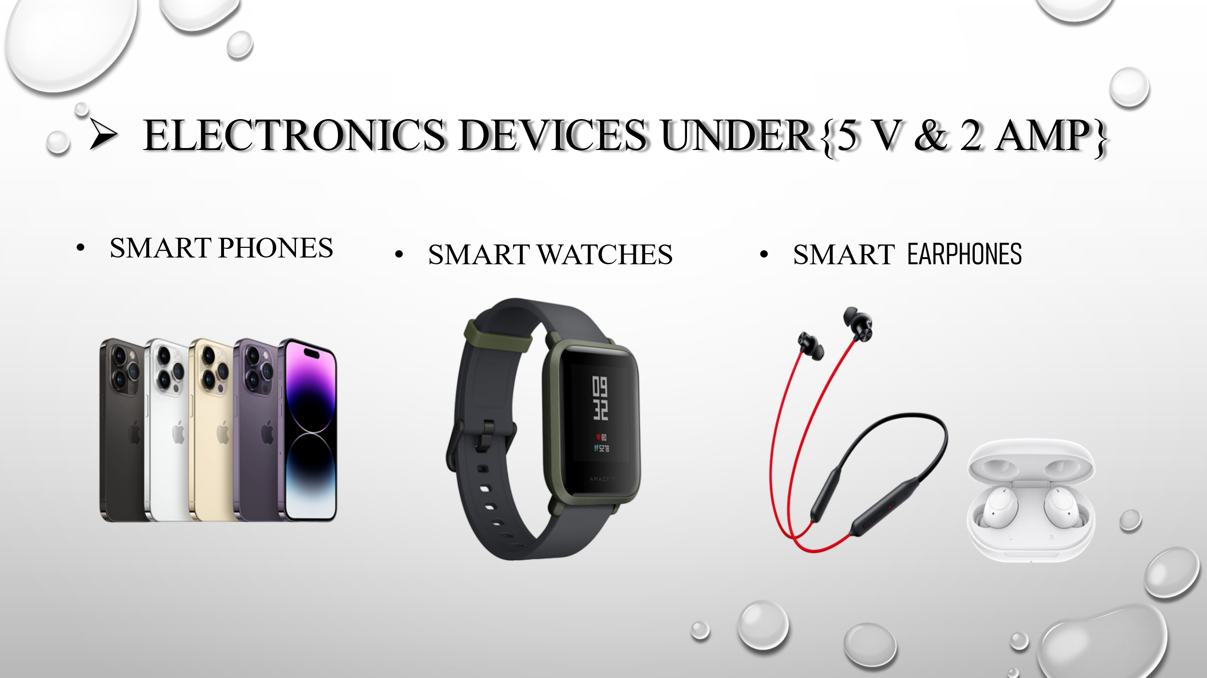

Fig.1.1 Devices Under 5 V & 2 Amp

This project aims to develop an independent power source specifically designed for such electronic devices. By integrating renewable energy harvesting methods, such as solar energy, thermoelectric conversion, or kinetic energy capture, along with efficient power management systems, the solution will provide a reliable and eco-friendly charging alternative. The power source will prioritize portability, ease of use, and compatibility with a wide range of devices, making it an ideal solution for both everyday use and emergency situations.

Through this innovation, we seek to address the growing demand for on-the-go charging while contributing to sustainable energy practices and enhancing user convenience.

CHAPTER-2

DISCPTION OF THE PROBLEM

* 1. Detailed Explanation of the Problem

Electronic devices, such as smartphones, tablets, and other gadgets, have become an integral part of daily life. These devices rely heavily on rechargeable batteries to function. However, the limited capacity of these batteries means they need to be recharged regularly, which creates several challenges for users.

* 1. Key Components for Charging
* **ElectricPower**:  
  Electric power is the fundamental energy source required to recharge batteries. It is typically accessed through wall sockets, USB ports, or other fixed sources. However, it is stationary and depends on infrastructure availability, making it non-portable.
* **Adapter**:  
  The adapter converts electric power from the source (such as an AC outlet) into a suitable form (e.g., DC power) for the device. It is portable, easy to carry, and widely available.
* **DataCable**:  
  The data cable connects the adapter to the electronic device and facilitates power transfer. It is also portable and adaptable for various devices.
  1. Core Problem
* While the adapter and data cable are portable, the **electric power source is not portable**, creating a dependency that restricts users to fixed locations for charging their devices. This creates significant challenges, particularly in the following scenarios:
* **Travel**: When on long journeys, access to power sources can be limited, leaving devices unusable.
* **Outdoor Activities**: In remote areas without electricity, such as during camping or trekking, recharging becomes impossible.
* **Emergencies**: During natural disasters or power outages, the inability to charge devices can hinder communication and access to vital information.
  1. Existing Solutions and Their Limitations

1. **Power Banks**:
   * Power banks are portable battery packs that store energy and can recharge devices on the go.
   * **Limitations**:
     + They require prior charging from a power source, creating a similar dependency on electric infrastructure.
     + Limited capacity, requiring frequent recharging of the power bank itself.

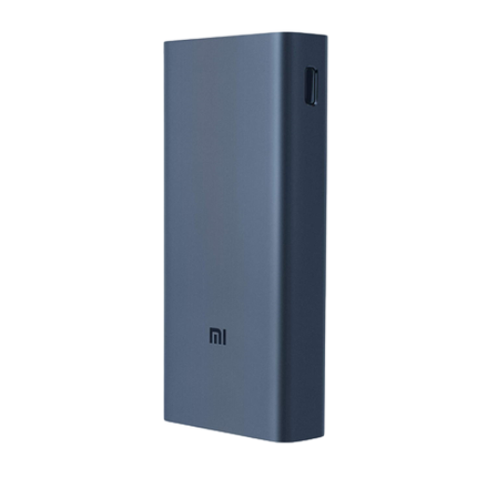

Fig.2.1 Power banks

1. **Kinetic Energy Solutions** (e.g., hand-crank chargers):
   * Devices that generate electricity through manual effort, such as cranking or pedaling.
   * **Limitations**:
     + Inefficient and labor-intensive.
     + Generates minimal energy, insufficient for modern devices.



Fig.2.2Hand-crank chargers

1. **Advanced Technologies (e.g., Atom Chargers)**:
   * Market solutions like compact chargers with faster-charging technology.
   * **Limitations**:
     + Still require access to a primary power source.
     + Do not address off-grid or emergency needs.

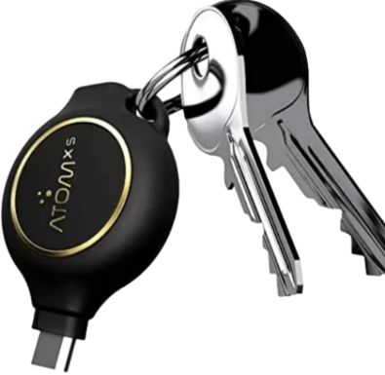

Fig.2.3 Atom Chargers

* 1. The Gap in Existing Solutions

Current solutions focus on portability and convenience but fail to address the core issue: independence from fixed power sources.

Users need a solution that combines portability, sustainability, and the ability to generate or store energy without depending on conventional electricity.

* 1. Need for Innovation

A truly portable charging solution must address the following:

* **Energy Independence**: A way to generate or store energy sustainably without relying on fixed power sources.
* **Efficiency**: Fast charging capabilities to minimize downtime.
* **Portability**: Compact, lightweight design for easy use during travel or emergencies.
* **Sustainability**: Environmentally friendly and energy-efficient technology.

This unmet need opens the door for innovation, such as **self-chargeable adapters**, which can provide a game-changing solution to the problem. Would you like further discussion or brainstorming on innovative approaches to address this issue?

CHAPTER-3

SOLUTION

Modified Adapter**:** The core of the solution lies in replacing the standard adapter with a modified one. This modified adapter is designed to eliminate the dependence on external electric power.

**No External Power:** The key feature of this solution is that it doesn't require any external electric power source to charge the mobile device.

* 1. Flowchart:

The flowchart visually represents the charging process:

ELECTRIC POWER

SOCKET/PORT

ADAPTER

DATA CABLE

CHARGING OF MOBILE

**F**ig.3.1Flow chart

* **Electric Power:** Initially, the system relies on electric power, but this step is eliminated with the modified adapter.
* **Socket/Port:** The power would typically be connected to a socket/port but this step is bypassed in the modified system.
* **Adapter:** The standard adapter is replaced with the modified one. This adapter is the crucial component enabling charging without external power.
* **Data Cable:** The data cable connects the modified adapter to the mobile device.
* **Charging of Mobile:** With the modified adapter and data cable, the mobile device can be charged without the need for external electric power.

* 1. Law of Conservation of Energy:

The text at the top of the image states: "According to energy conservation law - Energy can neither be created nor be destroyed but it can be transferred from one form to another form.

This fundamental law of physics signifies that the total energy in an isolated system remains constant. Energy can change forms (e.g., from potential to kinetic, or chemical to thermal), but the total amount of energy always stays the same.

* 1. Energy Transformations:

The flowchart depicts a specific sequence of energy transformations:

* **Magnetic Field Energy:** The process starts with energy stored within a magnetic field. This could be generated by various means, such as moving a magnet or passing an electric current through a coil.
* **Mechanical Energy:** The magnetic field energy is then converted into mechanical energy. This transformation is likely achieved through the interaction between the magnetic field and a moving object or a system with moving parts. For example, a motor uses magnetic fields to convert electrical energy into mechanical energy to rotate a shaft.
* **Electrical Power:** Finally, the mechanical energy is converted into electrical power. This step could involve a generator, where mechanical energy (like the rotation of a turbine) is used to induce an electric current.

MAGNETIC FIELD ENERGY

MECHANICAL ENERGY

ELECRICAL POWER

Fig.3.2 Flow of energy

CHAPTER-4

COMPONENTS USED

* 1. Magnets

Our neodymium arc magnets have a unique shape and are designed for use in permanent magnet motors and generators due to the configuration of their north and south polarities.

This arc neodymium magnet is made of top quality NdFeB magnetic materials under ISO 9001 quality systems. The magnet is magnetized through the thickness with SOUTH pole on the inner diameter. It is coated with Ni+Cu+Ni triple layers. 8 pieces of this arcs can form a circle.

**Neodymium N42 Arc Segment Magnet**

**South 37,5 mm O.R. x 33.5 mm I.R. x H 25 mm x Thick 4 mm 90° Degree**

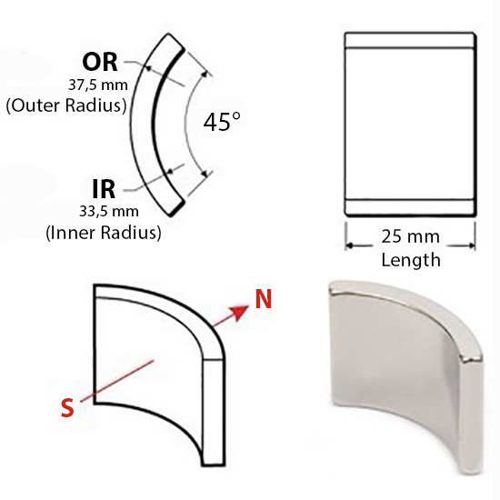

Fig.4.1 Neodymium magnets

**Details**

* STRONG NEODYMIUM MAGNET. Each Magnet Can Support A Vertical Flush From The Magnetic Face In Contact With A Soft Steel Surface Of An Equal Thickness From The Magnet Face
* PREMIUM COATING AND MATERIALS. Each Magnet Is Plated With Three Coats Of Nickel, Copper And Nickel For Superior Corrosion Resistance And A Smooth And Clean Finish
* 25mm high and 4mm thick, with an outer radius of 37.5mm and an inner radius of 33.5mm.
* The south pole of the magnet is on the inner radius and the north pole is on the outer radius.
* Four of these south arc magnets and four of the north version are required to form an 8-pin 360° ring.
* They are plated with three layers of nickel, copper and nickel to prevent corrosion and provide a smooth and clean surface
* These high-performance neodymium (N42) arc magnets are widely used in motors for both rotors and stators and have anisotropic orientation and a maximum operating temperature of 80 degrees Celsius.
* Magnetic motor designers and inventors
* Motor magnets and high-tech sector
* Wind Turbines, Wind Generators, Loudspeakers, Magnetic Hooks, Magnetic Holders, Car Filters

**Magnet force**

The forces have been determined at room temperature on a plate in polished steel (S235JR according to DIN 10 025) with a thickness of 10 mm (1kg ~ 10N). A maximum deviation of -10% compared to the specified value is possible in exceptional cases. Value is exceeded in general. Depending on the type of application (installation situation, temperatures, counter anchor etc.) the forces can be influenced enormously.

**Classy look and high-quality material**

Thanks to the elegant look of our Neodymium N42 Arc Segment Magnet North 37,5 mm O.R. x 33.5 mm I.R. x H 25 mm x Thick 4 mm, they can be placed in a clearly visible position.

* 1. DC Motor/Generator

Key Specifications:

1. Speed:

The motor operates at a high speed of 46,500 RPM (Revolutions Per Minute), making it suitable for applications requiring rapid rotation and precision.

1. Voltage and Current:

Voltage: Operates at 4.2 Volts DC, ensuring efficient power consumption.

Current: Draws a minimal current of 0.12A, making it energy-efficient.

1. Motor Dimensions:

Diameter: 6mm

Length: 15mm  
These compact dimensions make the motor ideal for small-scale projects and applications where space is limited.

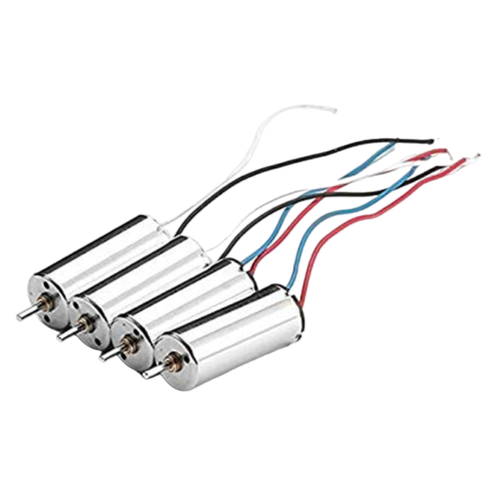

Fig.4.2 Dc motor/generator

* 1. Battery

**Detailed Description of the KP Original Lithium Polymer Battery**

**Key Specifications:**

1. **Battery Type:**

**Lithium Polymer (Li-Po):** Known for being lightweight, compact, and delivering high energy density, making it ideal for portable devices.

1. **Voltage:**

* **Output Voltage:** 3.7 Volts (DC)
* **Charging Voltage:** 4.2 Volts (DC)  
  This voltage range makes it compatible with many small electronic devices requiring stable and reliable power.

1. **Capacity:**

**400mAh:** Provides sufficient capacity for powering devices.

1. **Weight:**

**30 Grams:** Lightweight design, which is perfect for small, portable devices like drones and Bluetooth accessories.

1. **Model Name:**

**KP352224:** Identifies the specific design and dimensions of the battery, ensuring compatibility with devices that use this form factor.

1. **Net Quantity:**

**1 Battery (Included):** The package contains one fully rechargeable battery, ready for use.

1. **Reusability:**

**Rechargeable:** Designed for repeated use, ensuring cost-effectiveness and environmental sustainability.

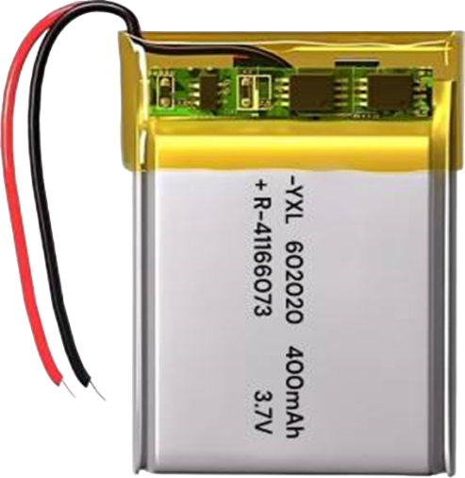

Fig.4.3 Dc battery

* 1. Boost Converter

**Detailed Description of the LED Dual USB 5V 2.4A Micro/Type-C Mobile Power Bank Charging Module**

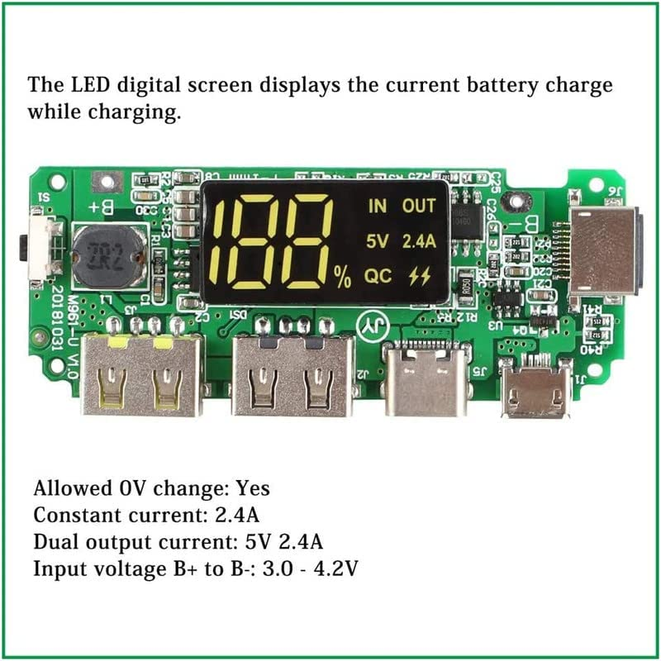

Fig.4.4 Boost Converter

**Product Overview:**

This **LED Dual USB Mobile Power Bank Charging Module** is a versatile and compact charger designed to support lithium battery packs. With advanced circuit protection features, dual USB outputs, and compatibility with multiple types of USB cables, this module is ideal for building custom power banks, powering portable devices, and ensuring battery safety.

**Key Specifications:**

* **Brand & Model:**
  + **Brand:** Electrolight
  + **Model Number:** USB 5V 2.4A LED Dual Micro/Type-C USB Mobile Power Bank Charging Board USB 18650
* **Material and Dimensions:**
  + **Material:** Epoxy (durable and lightweight)
  + **Size:** 6.5 cm × 2.5 cm × 0.05 cm
  + **Weight:** 10.8 grams
* **Input & Output Specifications:**
  + **Input Voltage:** 3.0 - 4.2V (B+ to B-)
  + **Dual Output Current:** 5V 2.4A (suitable for fast charging external devices)
  + **Charging Compatibility:** Supports three types of USB cables—Micro USB, Type-C, and Lightning (iPhone).
* **Power Source:**
  + Operates using a **battery** or a **5V DC power source**, making it flexible for various applications.
* **Battery Protection Features:**
  + **Overcharge Protection:**
    - Detection Voltage: 4.20 ± 0.05V
    - Release Voltage: 4.10 ± 0.05V
    - Detection Delay Time: <200ms
  + **Overdischarge Protection:**
    - Detection Voltage: 3.0 ± 0.10V
    - Release Voltage: 3.10 ± 0.10V
    - Detection Delay Time: <100ms
  + **Short Circuit Protection:**
    - Detection Delay Time: <50µS
    - Release Condition: Cut off the load.
* **Current and Power Consumption:**
  + **Normal Current Consumption:** Max 60µA
  + **Standby Current Consumption:** Max 50µA
  + **Max Continuous Charge/Discharge Current:** 1.5A (charge) / 2.4A (discharge)
* **LED Indicator Display:**
  + The **LED digital screen** shows:
    - Battery charge percentage during charging.
    - Current battery power during discharging (saves display after 30 seconds and resumes with a double-click).
  + Ensures accurate battery indication after a full charge/discharge cycle.

**Key Features:**

* **Multi-USB Compatibility:**
  + Supports **Micro USB**, **Type-C**, and **Lightning cables**, making it suitable for a wide range of devices.
* **Portable Power Supply:**
  + Acts as a **backup power source**, delivering 5.0V/3.0A via USB 2.0 output for external devices.
  + Uses a built-in battery for portable convenience.
* **Advanced Circuit Protection:**
  + Prevents **overcharging**, **overdischarging**, and **short circuits** to enhance battery life and device safety.
  + Built-in detection and release mechanisms ensure stable performance.
* **Button Functionality:**
  + **Power Display Control:** Press and hold the button to display the power level on the LED screen.
  + The display can be resumed with a double-click after it saves automatically.
* **Working Conditions:**
  + **Temperature Range:** -5°C to 45°C
  + Designed to operate reliably in standard environmental conditions.

**Important Notes:**

* **Battery Polarity:**
  + Connect the **positive pole** of the battery to **B+** and the **negative pole** to **B-**. Reversing the polarity may damage the module permanently.
* **Charger Selection:**
  + Use a **proper charger with auto-cutoff** to prevent overcharging and overheating.
* **Avoid Overheating:**
  + Charge in a well-ventilated environment and avoid exposing the module to extreme temperatures.
  1. Switches

**Detailed Description of the Rocker DPDT One-Way Switch**

**Product Overview:**

This **Rocker DPDT (Double Pole Double Throw) One-Way Switch** is a reliable and efficient electrical component designed for seamless on/off control of electrical devices. With a compact design, wall-mount compatibility, and support for high voltage and current, it is an ideal choice for home, industrial, and DIY electrical systems.

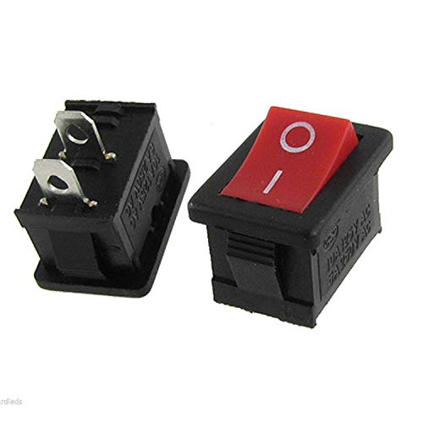

Fig.4.5 Switch

**Key Specifications:**

1. **Operation Mode:**
   * **ON-OFF:** The switch operates in a simple on/off mode, providing a straightforward mechanism to control the flow of current to a device or circuit.
2. **Current Rating:**
   * **3 Amps:** Supports a maximum current of 3 amps, ensuring compatibility with low- to moderate-power devices.
3. **Operating Voltage:**
   * **250 Volts (AC):** Designed to handle up to 250 volts, making it suitable for a variety of residential and industrial applications.
   1. Hold switch

This **Micro Momentary Tactile Push Button Switch** is a compact, high-precision push-button designed for momentary ON-OFF operations. It is widely used in electronics, household appliances, and DIY projects due to its durability, small size, and reliable performance.

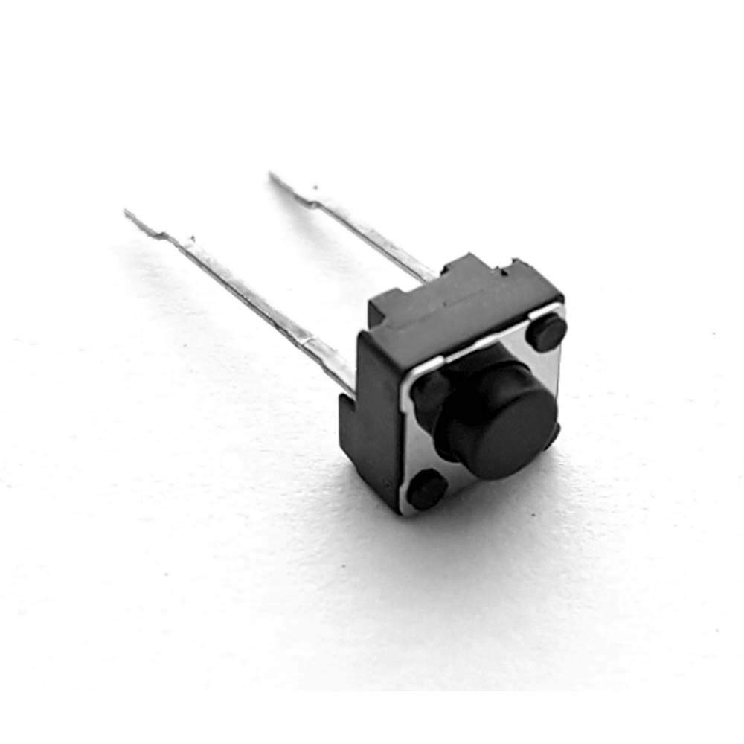

Fig.4.6 Hold button

**Key Specifications:**

* **Operation Mode:**

**ON-OFF (Momentary Contact):** The switch maintains contact only when pressed and disconnects when released.

* **Current Rating:**

**1 Amp (DC):** Supports a maximum current of 1A, suitable for low-power applications.

* **Operating Voltage:**

**10 Volts (DC):** Works efficiently within low voltage ranges, making it ideal for circuit boards and electronic devices.

**CE Certified:** Complies with safety and quality standards.

CHAPTER-5

CIRCUIT DIAGRAM

The circuit diagram integrates various components that work together to achieve a self-sustaining energy generation and charging system. Below is the detailed explanation of the working principle based on the circuit diagram:

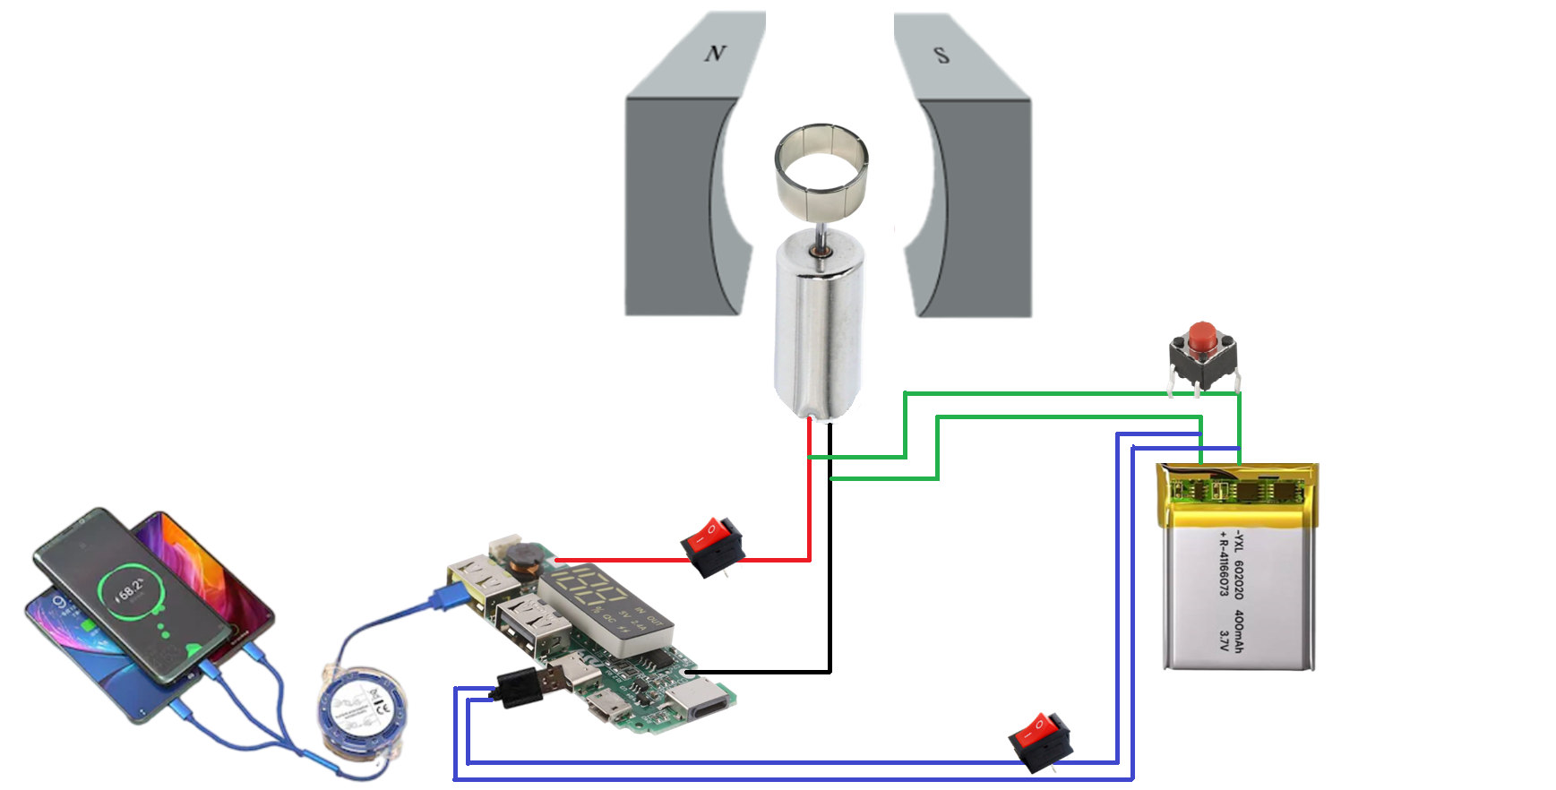

Fig.5.1 Circuit diagram

5.1 Battery Source and Motor Operation

* **Initial Power Supply**:
  + The circuit has a battery source connected to a switch. When this switch is closed, the battery supplies power to the DC motor.
  + The motor starts rotating due to the supplied current.
* **Magnetic Field Assistance**:
  + The rotor of the motor is surrounded by a **magnetic field arrangement** (represented by the North and South poles of the permanent magnets in the circuit diagram).
  + This magnetic field plays a crucial role in maintaining the rotation of the motor, even when the battery power is disconnected.

5.2 Transition to Generator Mode

**Electromagnetic Induction**:

* + Once the motor starts rotating, the surrounding magnetic field induces a flow of current in the motor windings, based on **Faraday's Law of Electromagnetic Induction**.
  + After disconnecting the battery by opening the switch, the motor continues rotating, effectively working as a generator.
  + The rotor movement within the magnetic field generates an **alternating current (AC)**.

5.3 Conversion of Electrical Output

* **Output Regulation via Converter Circuit**:
  + The generated AC from the motor is directed to a **converter circuit**. This is represented in the diagram as a unit with connections to a switch.
  + When the converter switch is closed, it stabilizes the generated power into a **constant DC output** of 5V and 2A, suitable for charging electronic devices.
  + The converter ensures that the output voltage and current are regulated and consistent, preventing fluctuations that could harm the connected devices.

5.4 Power Storage

**Rechargeable Battery Integration**:

* + The system includes a rechargeable battery that acts as an intermediary power storage unit.
  + The generated power from the motor can be stored in this battery when the motor is running. This stored power ensures that charging can continue even when the motor is stopped.

5.5 Charging the Devices

**USB or Power Output Ports**:

* + The regulated 5V/2A output is directed to the USB ports or other output terminals, as shown in the diagram.
  + These terminals are used to charge external devices such as smartphones, power banks, or other USB-compatible devices.

# 

CHAPTER-6

WORKING

6.1 Step-by-Step Working Summary

* **Switch ON Battery Supply**:

Close the battery switch to start the motor rotation.

* **Switch OFF Battery Supply**:

Open the battery switch once the motor reaches a sufficient rotational speed. The motor transitions into generator mode due to the surrounding magnetic field.

* **Switch ON Converter Circuit**:

Close the converter switch to regulate the generated power and convert it into a usable DC output.

* **Charge Devices**:

Connect electronic devices to the output ports for charging. The converter ensures a steady power supply.

6.2 Key Features of the System

* **Energy Efficiency**: The system harnesses the kinetic energy of the rotor for power generation without continuous battery dependence.
* **Portability**: The inclusion of a rechargeable battery and standard USB output makes it portable and user-friendly.
* **Sustainability**: The self-sustaining mechanism reduces reliance on external power sources, promoting eco-friendly energy solutions.

This detailed explanation provides a clear understanding of how the system works based on the circuit diagram. Let me know if you'd like to dive deeper into specific components or principles!

CHAPTER-7

FUTURE PLAN

The device holds immense potential for future development and application, particularly in expanding its range and power capacity to support larger and more power-hungry electronic devices like laptops and other high-energy equipment. Below is a detailed description of the envisioned enhancements:

7.1 Increasing the Power Range

Objective: To enable the device to charge larger devices like laptops, which typically require higher voltages (e.g., 19V) and greater power output (e.g., 45W to 100W), compared to smartphones that require 5V and 2A.

7.2 Supporting Larger Devices

Objective: Expand the device's usability to power larger electronic devices like laptops, tablets, and potentially even small appliances.



Fig.7.1 laptop

7.3 Steps to Achieve This:

* **Increased Current and Voltage Output**

Enhance the power output to deliver 19V/3A (57W) or higher to meet the requirements of modern laptops.

Incorporate power delivery (PD) technology to allow dynamic voltage adjustments (e.g., 5V, 9V, 12V, 15V, 20V) for compatibility with a variety of devices.

* **Enhanced Power Capacity**

Objective: To improve the overall efficiency and reliability of the device for high-energy devices.

* **Real-World Applications**

With these upgrades, the device will no longer be limited to charging smartphones but will become a versatile solution for a variety of use cases.

Laptops and Tablets: Efficient charging for workstations and high-end devices.

7.4 Future Vision

* **Scalability:**

Scale up the design for even larger applications, such as powering outdoor equipment or small electric vehicles.

* **Durability and Portability:**

Design a compact and rugged version for outdoor enthusiasts, hikers, or remote workers who need reliable and portable energy sources.

* **Eco-Friendly:**

Use recyclable materials and renewable energy sources to make the device more sustainable and environmentally friendly.

CHAPTER-8

CONCLUSION

This project offers an innovative and sustainable solution to address the challenges of portable power generation. By leveraging the principle of electromagnetic induction, the device is capable of generating electricity independently, making it a reliable and eco-friendly alternative for charging electronic devices. Its compact and portable design ensures convenience and usability, especially for individuals on the go, outdoor enthusiasts, and during emergencies where conventional power sources may not be accessible.

Looking forward, the device holds immense potential for scalability. With enhancements to its power capacity and operational range, it can cater to high-energy devices like laptops, expanding its applicability to a broader range of consumer needs. This project not only addresses the immediate need for portable charging but also sets the foundation for future advancements in energy efficiency and green technology, contributing to a more sustainable and connected world.

CHAPTER-9

REFERENCES

* **Faraday, M.** (1831). *Experimental Researches in Electricity*. This foundational work explains the principles of electromagnetic induction used in the motor-generator setup.
* **Google**: [www.google.com](http://www.google.com/). Used for general searches and sourcing preliminary data for the project.
* **IEEE Explorer**: [www.ieeeexplorer.com](http://www.ieeeexplorer.com/). Provided access to research papers and technical documents related to portable power solutions and electromagnetic systems.
* **"Joint Consultation Paper: Western Metropolitan Melbourne Transmission Connection and Sub-transmission Capacity"** (PDF). Jemena, Australian Energy Market Operator. Retrieved 4 February 2016. Relevant for understanding energy distribution and scaling the power output of the project.
* **Stockton, Blaine.** *"Design Guide for Rural Substations"*. USDA Rural Development. United States Department of Agriculture. Retrieved 4 February 2016. Referenced for technical aspects of substation design, offering insights into energy management.
* **Steinberg, Neil.** *"Lights On but Nobody Home: Behind the Fake Buildings that Power Chicago"*. Retrieved 14 December 2013. Explored innovative energy concepts and solutions.
* **"Transformer Fire Video".** Meta Café. User: Eagle Eye. Retrieved 4 February 2016. Used for understanding safety aspects in power systems.
* **Donald G. Fink, H. Wayne Beatty.** *Standard Handbook for Electrical Engineers, Eleventh Edition.* McGraw Hill, 1978. ISBN: 0-07-020974-X. Chapter 17: Substation Design. Referenced for engineering calculations and design concepts in electrical systems.
* **R. M. S. de Oliveira and C. L. S. S. Sobrinho.** (2009). *"Computational Environment for Simulating Lightning Strokes in a Power Substation by Finite-Difference Time-Domain Method"*. IEEE Transactions on Electromagnetic Compatibility, 51(4): 995–1000. doi:10.1109/TEMC.2009.2028879. This provided theoretical validation for electromagnetic interference handling in the project.